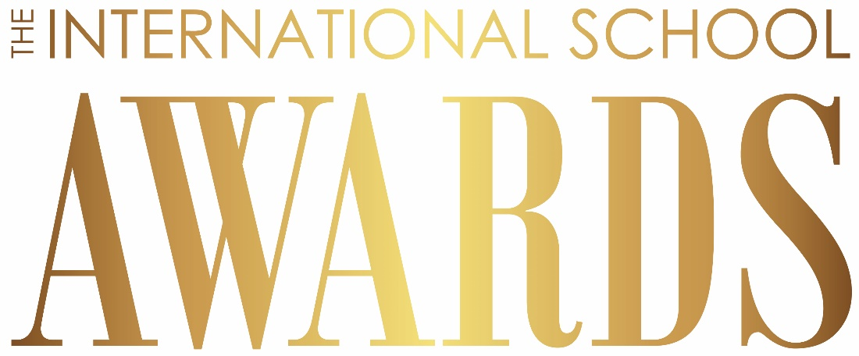

International School Awards 2022
Application Form
** International Impact **

You must complete all sections of this form in one submission. You will be unable to amend or add to this application later, so please make sure you have all content ready before submitting.

Word count note: It is essential to follow the word count limits. Any submissions over the identified word limit will be removed before your application is sent to the judges. This means that you must keep your submissions within the word count required.

International impact
This award will recognise a school initiative that demonstrates how international education and the school ethos have had a positive impact within the locality and/or on a global scale. Evidence should include a clear statement of how your initiative has gone beyond what the school would be doing as an effective international school. This could be an international initiative relevant to COVID-19 or otherwise, but must be achieving international impact in a way that goes beyond supporting the school community through a global pandemic. Your application must focus on how and why one initiative is impacting your school including:
- How and why the initiative has made a difference beyond the context of the school itself in a way that shares an international dimension that gives students a deeper understanding of what it means to live and serve in an internationally-minded way
- How and why the initiative has had impact on the international context of your school, either locally or on a global scale, through evidence that has been collected to track the impact of the initiative
- How and why the initiative includes the student voice and/or student action as part of the initiative
- How and why the initiative has addressed a challenge or opportunity in a way that has directly impacted the school and demonstrates the potential for longer-term development as a sustainable initiative for the school
- How and why the initiative includes strategies that enable it to be shared beyond the wider school community e.g. with other international schools and/or could be used to help bring about best practice in their local educational communities (evidence of this could include visibility of the initiative on a public website, public access YouTube videos, community engagement, conference or workshop presentation, publication in publicly accessible media)

Contact Details

Contact Name: Click here to enter name.
Contact Position: Click here to enter position.
Contact Telephone Number: Click here to enter number.
Email Address: Click here to enter email.

Details of your school

School Name: Click here to enter name.
School Address: Click here to enter address.
School Telephone Number: Click here to enter number.
School Website: Click here to enter website.
Name of Head of School: Click here to enter name.
Email Address of Head of School: Click here to enter email.
Current Student Enrolment: Click here to enter enrolment.
Current Number of Full Time Staff: Click here to enter number.

Overview of your school (max. 100 words – note that any words over the 100 word limit will be removed):
Click here to enter text.

Details of your initiative
Summary of initiative (max. 250 words – note that any words over the 250 word limit will be removed. This applies to all word limits):
Click here to enter text.

How and why the initiative has made a difference beyond the context of the school itself in a way that shares an international dimension that gives students a deeper understanding of what it means to live and serve in an internationally-minded way? (max. 250 words):
Click here to enter text.

How and why the initiative has had impact on the international context of your school, either locally or on a global scale, through evidence that has been collected to track the impact of the initiative? (max. 250 words):
Click here to enter text.

How and why the initiative includes the student voice and/or student action as part of the initiative? (max. 250 words):
Click here to enter text.

How and why the initiative has addressed a challenge or opportunity in a way that has directly impacted the school and demonstrates the potential for longer-term development as a sustainable initiative for the school? (max. 250 words):
Click here to enter text.

How and why the initiative includes strategies that enable it to be shared beyond the wider school community e.g. with other international schools and/or could be used to help bring about best practice in their local educational communities (evidence of this could include visibility of the initiative on a public website, public access YouTube videos, community engagement, conference or workshop presentation, publication in publicly accessible media)? (max. 250 words):
Click here to enter text.

Photographs and video
We encourage your school to submit up to 5 photographs and one 30-second video to support your application.
It can include your students, staff or simply good recorded film sequences telling your initiative story.
Your video will be the chance for your school to explain your initiative in a visual and authentic way and promote your initiative as well as your school to a global audience.

Some shortlisted school photographs and/or video will be featured on the awards website, within social media and will be played at the awards event in January 2022.

Photographs and video technical requirements
- Any photographs must be high resolution jpegs
- Each photograph must be supported with a short explanatory caption
- Video up to 30 seconds in length
- Video must be highest quality possible (HD 1280x720 or Full HD 1920x1080)
- Video must be in mp4 or mov file format
- Please include links to your photo and/or video submissions here (photo albums or videos via social media links preferable, for more details see our application guidelines):
Click here to enter text.

Important: Rights clearance and consent for all application copy, photographs and video submitted
Your submitted application copy, photographs and video may be used to promote the International School Awards during 2022 and in future years. It may be featured on the ISC Research or International School Leader Magazine websites and social media channels as well as during the awards ceremony itself.

☐ Please check the box giving consent to the following: We confirm that we have obtained the permission from all protagonists captured in the school photographs, films and/or raw clips submitted and that any of the submitted material, edited or unedited, can be shown to promote international school award submissions on the International School Awards website, social media channels and on the big screen during the awards ceremony.

Please send your completed application form, consent form, photos, and video to applications@iscresearch.com
No later than Thursday 30th September 2021. Any applications after this date will not be accepted.

